NWAVE DEVELOPMENT KIT V3
USER MANUAL

Table of Contents
1. Main features of this Development Kit 2
2. Getting Started 3
2. 1. IAR Embedded Workbench (IAR EW) Installation 3
2. 2. Simplicity Studio installation 3
2. 3. Getting Git 4
2. 4. Getting Nwave example for IAE EW from Git repository 5
2. 5. Open Workspace in IAR EW 8
2. 6. Open Workspace in Simplicity Studio 8
2. 7. Open main.c file and select an example 8
2. 8. Connection J-Link programmer to the Development Kit 9
2. 9. Compile and Flash the device in IAR EW 9
2. 10. Compile project in Simplicity Studio 10
2. 11. Create a connection in serial terminal programme 10
2. 12. Sending Nwave messages 10
2. 13. User Application 11
3. AT-Commands 12
3. 1. Setting carrying frequency and bandwidth 12
3. 2. Sending messages by Nwave protocol 12
3. 3. Receiving by Nwave Protocol-E 13
3. 4. Getting a serial number 13
4. Nwave Library API 13
4. 1. Setting carrying frequency and bandwidth 13
4. 2. Sending messages by Nwave protocol 14
4. 3. Receiving messages by Nwave protocol 14
5. Peripheral Devices Sharing 14
Table 1. The Device Pinout on X4 15
Table 2. The Device Pinout on X3 16
6. Bootloader 16
6. 1. Loading a firmware by means of the bootloader 17
6. 2. Flashing bootloader into device 18
7. Electrical Scheme 19
8. Bill of Materials 20
9. Revision History 20

1. Main features of this Development Kit
This Development Kit is purposed to give user a capability to evaluate and use RM3 radio module and a software library in a variety of different applications. It is typically used in such application field as telemetry, but can find a wider applying, e.g. radio networks with ultra low power consumption.
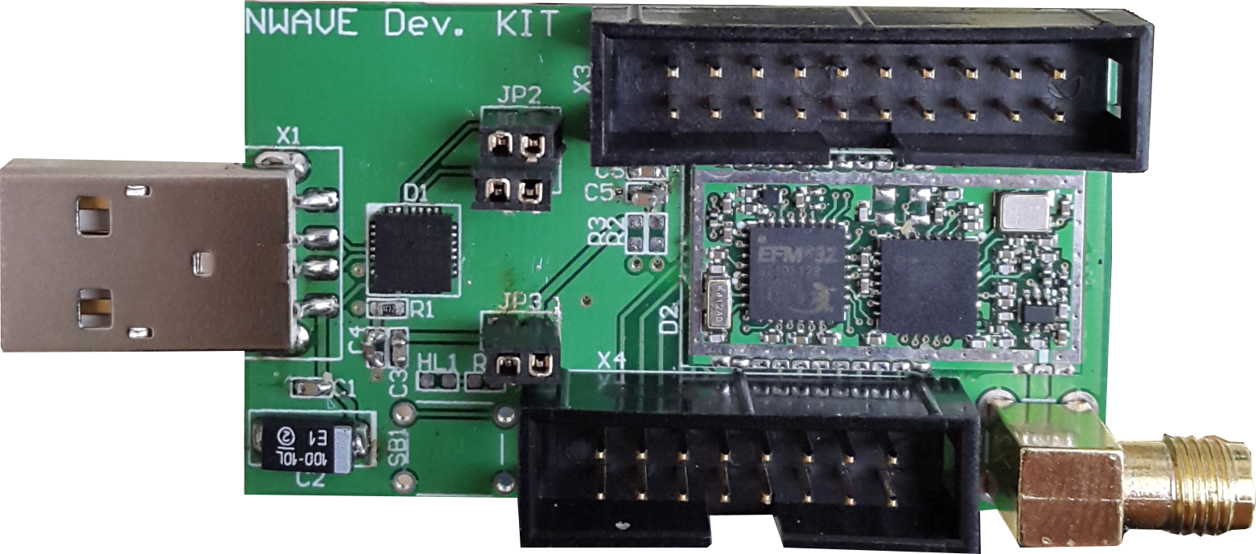
USB
Jumpers J1, J2, J3
X4 Pinouts Connector
X2 Antenna Connector
X3 JTAG Connector

- Easy USB connection to PC or direct UART interface
- AT-commands set via UART / USB-Serial to work in the modem mode
- Capability to embed up to 128 KB* of user firmware on MCU flash including communication API supplied as a library
- Access to all Cortex-M3 features and the EFM32G210F128 or EFM32TG210F32 MCU peripherals
- Programming templates and examples of simple telemetry applications
- Support for ARM Cortex Microcontroller Software Interface Standard (CMSIS)
* The firmware code size can be up to 128 KB according to this MCU flash size and NWAVE library size is about 9 Kb only. There is a limitation of code size caused by IAR compiler free license which is 32Kb as maximum of compilable code. The full license has no such a limitation and can be purchased from IAR. However, there is no code size limitation when project is built in Simplicity Studio using GNU C Compiler (gcc). The gcc is not limited by code size. In the current version of the Development Kit user package both IAR EW and Simplicity Studio with gcc are supported.
A bootloader can be flashed to the device in order to allow user to program the device via serial port without J-Link adapter. When the bootloader is used it occupies 8 Kbytes of MCU flash.

2. Getting Started
Here is a Quick Start instruction describing how to send Nwave messages.

2. 1. IAR Embedded Workbench (IAR EW) Installation
For getting an evaluation software follow the next link:

http://supp.iar.com/Download/SW/?item=EWARM-EVAL

After starting IAR EW you will be offered to select a license type: a 30-day time limitation or a 32Kbytes code size limitation.

2. 2. Simplicity Studio installation
Download Simplicity Studio from the next link:
http://www.silabs.com/products/mcu/Pages/simplicity-studio.aspx
After installation and first start let the software complete the updates downloading.

2. 3. Getting Git

http://git-scm.com/download/win

Run the installation.

Tick Git Bash Here and Git GUI Here.

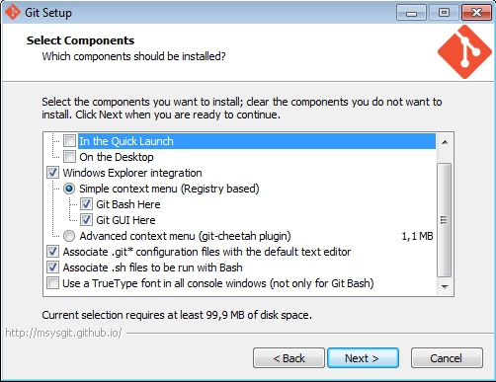

Select the command line option.

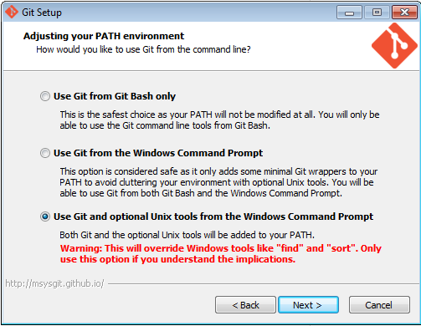

Note: if you select the last option it is going to override Windows tools like “find” and “sort”

Select the line ending conversions.

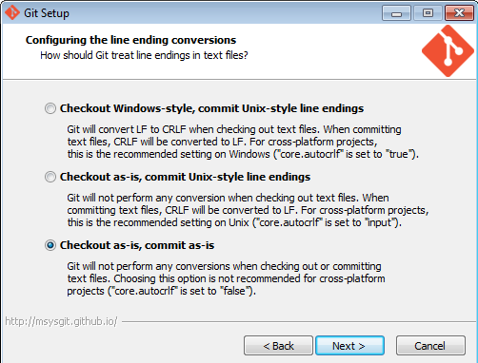

2. 4. Getting Nwave example for IAE EW from Git repository

Git has two interfaces: Command Line and GUI.

Getting a repository from the Command Line Interface run Git Bash

Type: git clone https://github.com/nwavetec/nwave.git
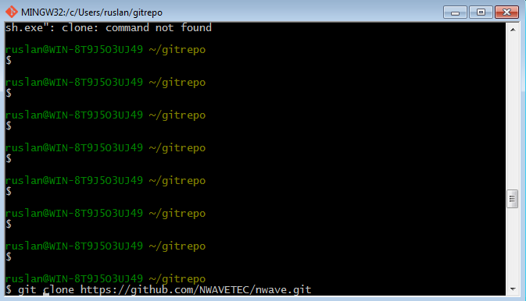

Check the content of this directory (run ls) it should show files:

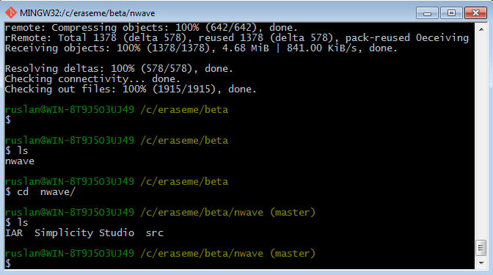

Getting a repository form the GUI run Git GUI.

At the first start select Clone Existing Repository
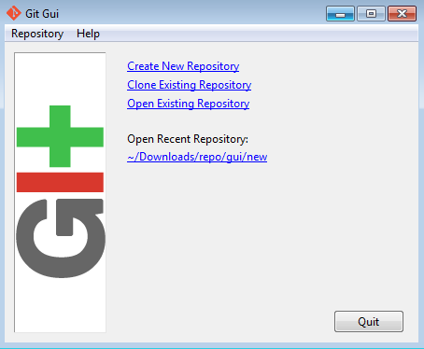

Type in the repository name and the directory name which will be created after this step.

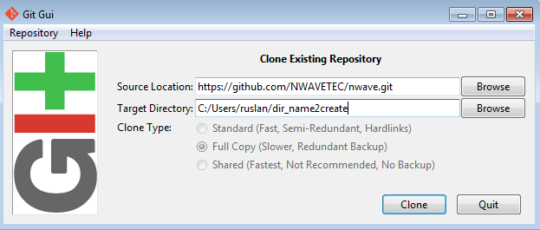

Press Clone and it will show the process of getting a repository.

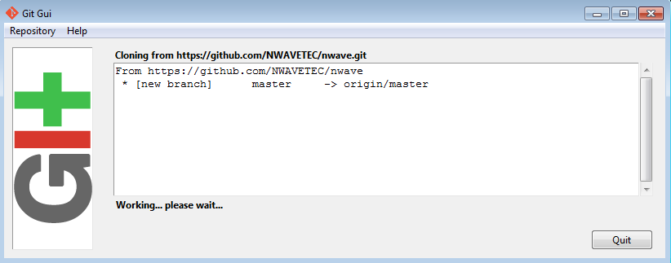

Then it finishes with showing this window below, now the project files are placed in the given directory:
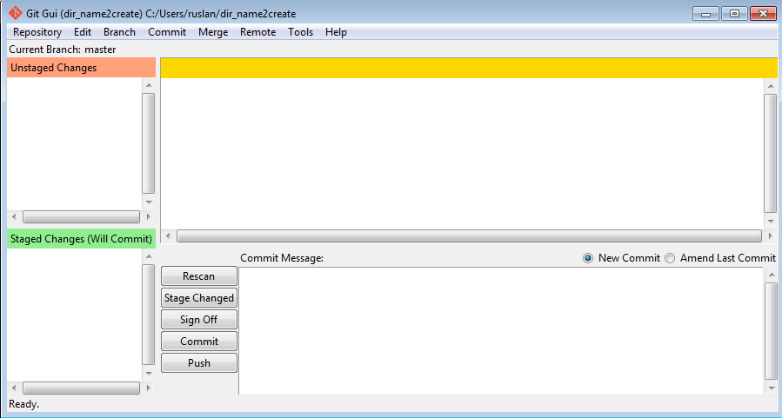

2. 5. Open Workspace in IAR EW
Open a workspace with file nwave_rm3_templates.eww which is placed at the top level of the cloned nwave directory.

2. 6. Open Workspace in Simplicity Studio
Run Simplicity IDE and click menu File->Switch to Workspace->other and select subfolder called Simplicity Studio under clonned nwave folder.

2. 7. Open main.c file and select an example
Select an example by editing this string:
#define EXAMPLE_CODE UART_2_RM

UART_2_RM means to include a simple example code which demonstrates how to use Nwave API, in particular sending upcoming to UART data directly to the radio module transmitter.

AT_PARSER means to include an example code of the parser of AT-commands which allows user to operate with the transmitter by AT-commands. The parser listens to the specific AT-commands on the serial port. These commands are described below in AT-Commands section.

2. 8. Connection J-Link programmer to the Development Kit

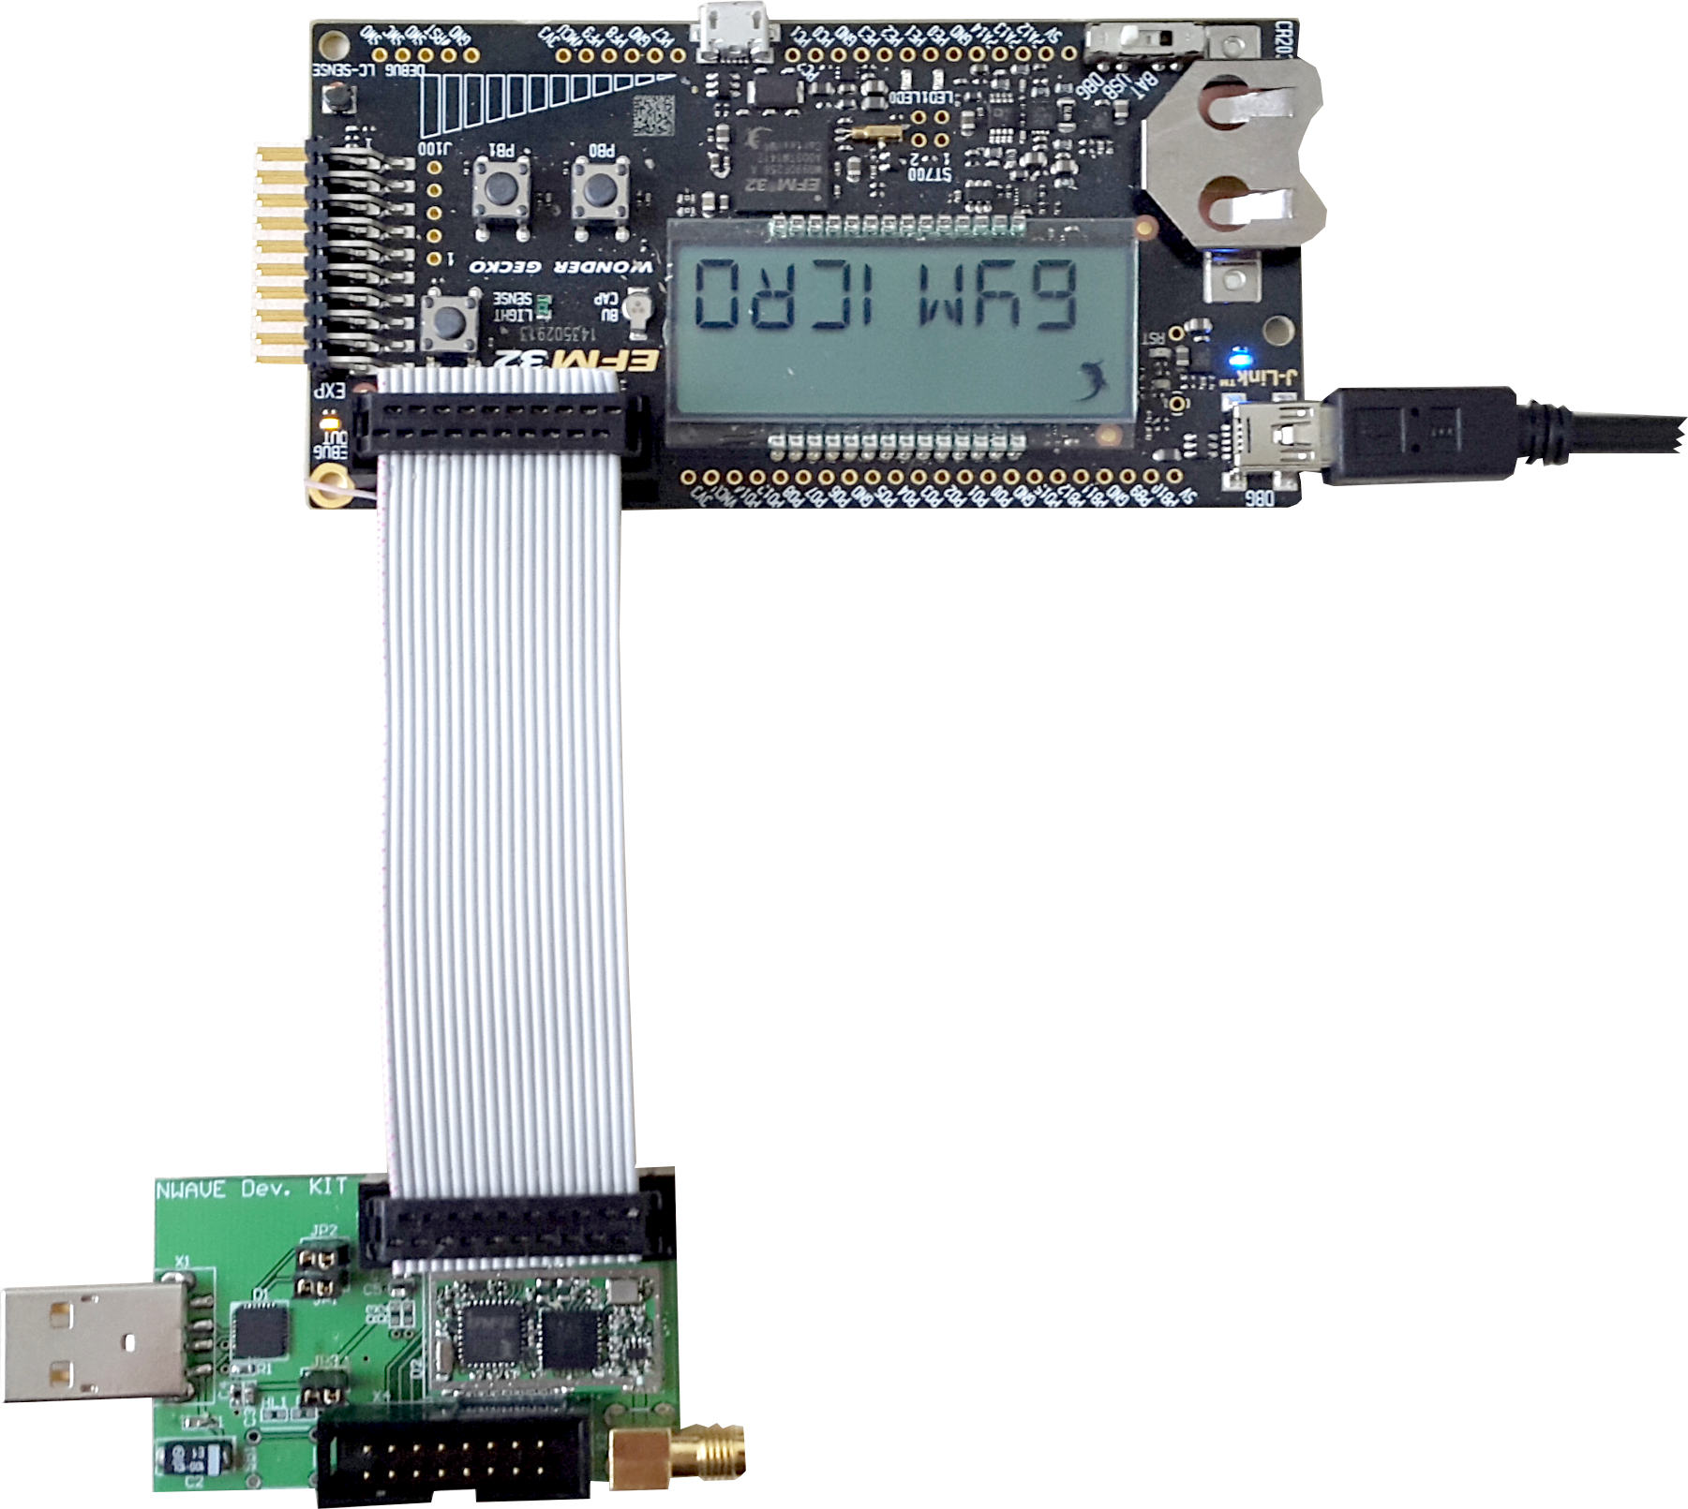
JTAG J-Link Cable
to X3 connector
USB to PC

2. 9. Compile and Flash the device in IAR EW
In open project press F7 to compile it or CTRL+D to compile, flash and debug the device *. The same action can be performed via Download and Debug button, see at the picture:
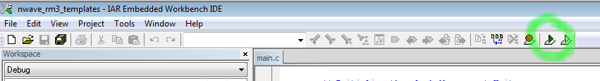
* To Download and Debug in hardware you need to connect JTAG J-Link adapter (or any starter kit, for instance, STK3200 or STK3300) to the X3 connector. Otherwise it is possible to trace the firmware code in Simulator which can be alternatively chosen in Debug option of the project. By default it is set to JTAG J-Link adapter.

2. 10. Compile project in Simplicity Studio
Having a project open (see 2. 6. Open Workspace in Simplicity Studio) click at the build button to compile as it is shown at the picture below/
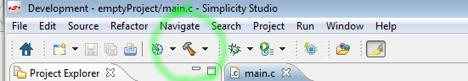

2. 11. Create a connection in serial terminal programme
Connect the Development Kit to the USB port of your computer. The Development Kit has a USB-to-Serial converter so it should appear as an additional serial port in the device list on your system.
In your terminal programme* create a new connection, select this new serial port and and set the parameters for the connection as below:
Baud rate: 9600
Data bits: 8
Stop bits: 1
Parity: none
Handshake(Flow Control) Hardware: none
Handshake(Flow Control) Software: none

* Tera Term or Putty can be used as terminal programmes free of charge.

2. 12. Sending Nwave messages
The API of Nwave Library is described in the section Nwave Library API.

Depending on selected example code in main.c file by defines AT_PARSER or UART_2_RM user can input either AT-Commands or data bytes directly to the radio transmitter. Both examples demonstrate using an API of nwave_unb library and send Nwave messages.

Note: In AT_PARSER example user basically needs to set carrying frequency and bandwidth in Hz by «AT+FREQ=...» command and send data by «AT+SEND=...» command. In UART_2_RM example user needs to care about setting a proper value carrying frequency by calling NWAVE_Set_Frequency(...) function (see section Nwave Library API).

2. 13. User Application
The provided source code is a template which allows simply embed a user application. Its structure is organized as two functions user_setup() and user_loop() called from main.
The user_setup() is supposed to include all initialization and it is called once.
The user_loop() is supposed to contain user application load.
An example code given below shows how simple transmission of user data can be done. In this example each 4 bytes coming to UART are sent to the radio module transmitter.
void uart_2_rm (void)
{
int watch_c;
while ((watch_c = NWRM_UART_GetChar()) >= 0) {
send_buf_len.send_buffer[i++] = watch_c;
if (i >= 4) {
unsigned char packetRec[256];
#warning "Set a proper frequency value for your environment"
/* NWAVE_Set_Frequency(866500000, 50000, 100); */
NWAVE_Set_Frequency(868800000, 50000, 100);
NWAVE_send(send_buf_len.send_buffer, 4 /*send_buf_len.len*/ , packetRec, PROTOCOL_B);
tfp_printf("Data sent.\n");
i = 0;
}
}
}
void user_loop (void)
{
uart_2_rm();
}
int main(void)
{
user_setup();
while (1) {
NWRM_RTC_Sleep();
user_loop();
}
}

3. AT-Commands

3. 1. Setting carrying frequency and bandwidth

Syntax:

«AT+FREQ=[Carrying_frequency],[Bandwidth]»

Carrying_frequency - central carrying frequency in Hz

Bandwidth - half-range which is added to and subtracted from central carrier frequency giving a full range in a result.

Example: AT+FREQ=868000000,25000

If success it returns «Ok», if failed - «Error»

3. 2. Sending messages by Nwave protocol

Syntax:

«AT+SEND=[&hex_byte1][&hex_byte2]..[ [&hex_byteN]]»

hex_byte - hexadecimal representation of a byte. Before each hexadecimal byte the symbol «$» is placed.

Example: AT+SEND=$23$0A$5D$5F

If success it returns «Ok», if failed - «Error»

3. 3. Receiving by Nwave Protocol-E
Syntax:

«AT+RCV=[&hex_byte1][&hex_byte2]..[ [&hex_byteN]]»

hex_byte - hexadecimal representation of a byte. Before each hexadecimal byte the symbol «$» is placed.

Example: AT+RCV=$23$1B$8E$7C

During one minute it returns a data stream of response from base station, or, if failed - «Error»

3. 4. Getting a serial number

Syntax:

«AT+SERIAL=?»

Example: AT+SERIAL=?

If success it returns a serial number of the device, e.g. «0000F556», if failed - «Error»

4. Nwave Library API
The Nwave Library is provided as a compiled library and it is stored in the nwave_unb.lib file. It is linked to the project. The unb.h is a header file with definitions for C functions of the library.
The Nwave library supports two protocols: Protocol-B for only sending messages to base station and Protocol-E for sending and receiving messages from base station.
The unb.h contains next function definitions:

4. 1. Setting carrying frequency and bandwidth
int NWAVE_Frequency_Set(unsigned long carrying_frequency, unsigned long bandwidth, int channels);

carrying_frequency – frequency of the low end of a range
bandwidth – frequency of the high end of a range
channels – channels number

4. 2. Sending messages by Nwave protocol
unsigned char NWAVE_send(unsigned char *packet, unsigned char length, unsigned char* packetRec, unsigned char protocol);
packet – pointer to the buffer for transmission
length – lengеh of the transmitted buffer
packetRec – pointer to the reading back buffer of Protocol-E; a format of data structure is described below
protocol – protocol type, is chosen by defined constants: PROTOCOL_B or PROTOCOL_E
Return: 0 is always returned when Protocol-B is used; Number of received bytes returned or 0 (if nothing received) when Protocol-E is used.

Here is a data structure format of reading back buffer of Protocol-E:
Modem Identifier: 3 Bytes
Message Identifier: 1 Byte
Message Body: 124 Bytes

NOTE: The packetRec is recommened to be a char array of at least 128 Bytes. This char array is for receiving base station reply (when Protocol-E is used).
NOTE: When Protocol-E is used this function waits as maximum for one minute to receive data, if data is not received during this timeout then the function returns 0 (to return variable, not to the buffer). If it happens it is recommended to send again after some delay and increase the delay each time user re-sends until a reply is received.
NOTE: User should not interrupt the execution of this function for more than 200us.

4. 3. Receiving messages by Nwave protocol
Receiving happens when Protocol-E is used. User can send data and receive the answer from base station using NWAVE_send(…) function described in 4.2

5. Peripheral Devices Sharing
On this Development Kit the USART 0 is used for communication with the radio device.
The CP2102 is the USB to Serial converter which is connected to the Low Energy UART of the MCU. It also converts 5V level of USB to the 3.3V level for the board power supply. This power supply line can be disconnected by removing J3 jumper. The RX and TX lines can be disconnected by removing J1, J2 jumpers.

Table 1 shows a pinout assignments on X4.

Table 1. The Device Pinout on X4
X4 Pin # and Name |  | Pin Functionality Alternatives | MCU Pin # and Name
Pin # | Pin Name | Pin Functionality Alternatives | Pin # | Pin Name
1 | GND
2 | VDD
3 | PC0 | ACMP0_CH0, PCNT0_S0IN, US1_TX | 5 | PC0
4 | PA1 | TIM0_CC1, I2C0_SCL, CMU_OUT1 | 2 | PA1
5 | PA0 | TIM0_CC0, I2C0_SDA | 1 | PA0
6 | PF1 | DBG_SWDIO, LETIM0_OUT1 | 26 | PF1
7 | PF0 | DBG_SWCLK, LETIM0_OUT0 | 25 | PF0
8 | PC14 | ACMP1_CH6, TIM0_CDTI1, TIM1_CC1, PCNT0_S1IN | 23 | PC14
9 | PC1 | ACMP0_CH1, PCNT0_S1IN, US1_RX0 | 6 | PC1
10 | PB11 | DAC0_OUT0, LETIM0_OUT0 | 10 | PB11
11 | PB13 | HFXTAL_P, LEU0_TX | 12 | PB13
12 | PC15 | ACMP1_CH7, DBG_SWV, TIM0_CDTI2, TIM1_CC2 | 24 | PC15
13 | PD4 | ADC0_CH4, LEU0_TX | 16 | PD4
14 | PD5 | ADC0_CH5, LEU0_RX | 17 | PD5
15 | PD6 | ADC0_CH6, LETIM0_OUT0, I2C0_SDA | 18 | PD6
16 | PD7 | ADC0_CH7, LETIM0_OUT1, I2C0_SCL | 19 | PD7
Table 2 shows a pinout assignments on X3.

Table 2. The Device Pinout on X3
X3 Pin # and Name |  | Pin Functionality Alternatives
Pin # | Pin Name | Pin Functionality Alternatives
1 | VDD
2 | GND
3
4 | GND
5
6 | GND
7 | DB2 | DBG_SWDIO, LETIM0_OUT1
8 | GND
9 | DB3 | DBG_SWCLK, LETIM0_OUT0
10 | GND
11
12 | GND
13
14 | GND
15 | RST
16 | GND
17
18
19
20 | GND

6. Bootloader
A device that you use may be prepared with a bootloader which means it was flashed to the MCU. The bootloader allows user to program the device via serial port (in fact, USB-Serial convertor) without J-Link adapter. When the bootloader is flashed to the device it occupies 8 Kbytes of MCU flash.
To flash the device by means of the bootloader you need to use an Nwave loader tool on the computer side. The Nwave loader is a part of entire bootloader git repository. To get it do next:
Run Git Bash
Type git clone https://github.com/nwavetec/boot.git

6. 1. Loading a firmware by means of the bootloader
Plug the developmint kit into the USB port of computer or connect it with the USB extension cable. After device power cycle happens there is a timeout interval of 2 seconds within which the entering to the bootloader mode is available. To do this user should run the Nwave loader tool right after device started during the specified time period (2s). The usage of the command for this is like:
winloader.exe firmware.bin portnumber
or
./linux_loader firmware.bin /dev/ttyUSBX
for example:
cd Tool/Win
winloader.exe at_cmds.bin 4
or
cd Tool/Linux
./linux_loader at_cmds.bin /dev/ttyUSB0
NOTE: The firmware binary file may be of two kinds of flash offset for program start entry and vectors: zero offset and 8 Kbytes offset (the bootloader size). This depends on linker file. To produce an application which will keep alive the bootloader user should use customized at_cmds.icf linker file (applied and set as default in Nwave project linker options) which puts an application to 8 Kbytes boundary. If user needs to use all flash size for an apllication including first 8 Kbytes then the default chip linker file should be used.
ATTENTION: The bootloader will be erased if an application is built with zero offset (by using default chip linker file). If this happened then the only way to program the device is a J-Link adapter. By means of the J-Link adapter user can restore the bootloader back again.

6. 2. Flashing bootloader into device
If your device does not have a bootloader or you have deleted/overwritten the MCU flash then you can put it into the device back again. You will need to have the J-Link adapter.
- Getting bin2hex utility
Download bin2hex utility. Extract zip-archive.
- Converting binary file to an Intel Hex file.
Run bin2hex.exe nwave_boot.bin nwave_boot.hex
- Getting the Simplicity Studio Production Programmer
Download Simplicity Studio Production Programmer . Extract zip-archive.
- Uploading a firmware to the MCU flash
Run programmer.exe
Press Browse button and select nwave_boot.hex file. Then press ProgramDevice button.

7. Electrical Scheme
The figure below is an electric circuit diagram of the NWAVE development kit.

8. Bill of Materials
The table below is a list of used mechanical and electronic components and their parameters.

9. Revision History
Here is a revision history for this document.
Author | Description of Changes | Date | Revision Number
Ruslan Gerasimov | Created | 15-04-2015 | 1.1
Ruslan Gerasimov | Bootloader and Protocol-E notes added | 01-05-2015 | 1.2

